Match the photo to the correct name.

1. 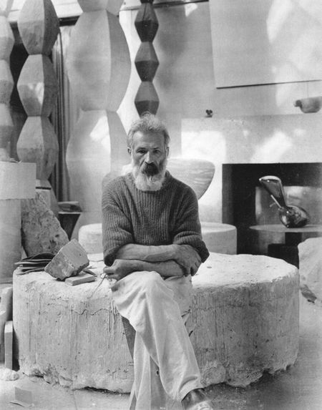 Sculptor
2. Constantin Brancusi
3. Ion Irimescu
4. Cornel Medrea
5. Oscar Han

Answer: a

1. 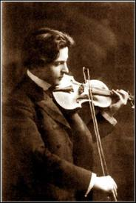 Composer&violinist
2. Ciprian Porumbescu
3. George Enescu
4. Dinu Lipatti
5. Anton Pann

Answer: b

1.  Gymnast
2. Cătălina Ponor
3. Andreea Răducan
4. Nadia Comăneci
5. Daniela Silivaş

Answer: c

1. 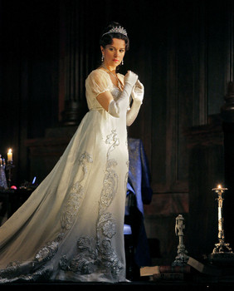 Soprano
2. Mariana Nicolescu
3. Hariclea Darclée
4. Virginia Zeani
5. Angela Gheorghiu

Answer: d

1. 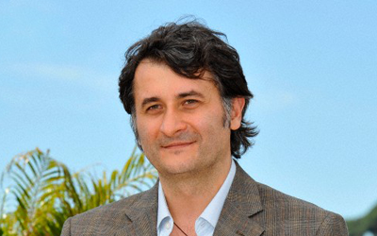 Film director
2. Sergiu Nicolaescu
3. Cristi Puiu
4. Jean Negulescu
5. Cristian Mungiu

Answer: b